1. To communicate with Redis DB through Spring Data, we need **Redis Template**.
2. 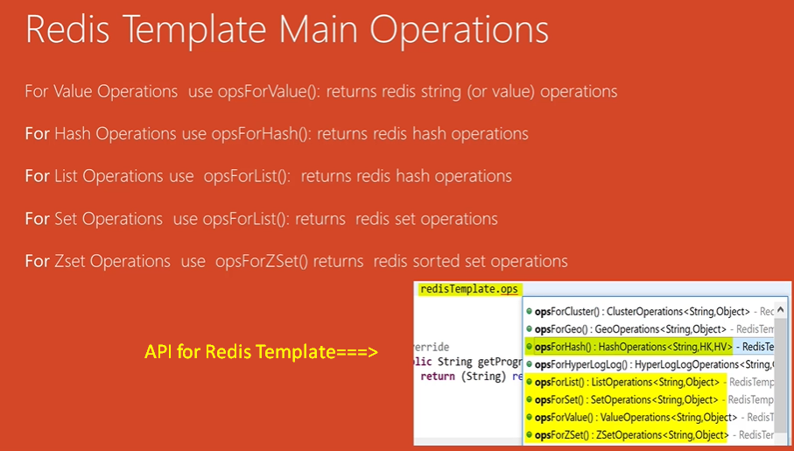
3. Through Redis Template, you can do all operations on Redis DB.